**Answers to Lab 1 Questions**

Here are the answers to the technical questions for your reference and to include in your lab report.

**1. Check and Enable Virtualization**

* **How to Check (Windows):** Open Task Manager (Ctrl+Shift+Esc), go to the "Performance" tab, and look for "Virtualization" at the bottom-right. It will say "Enabled" or "Disabled".
* 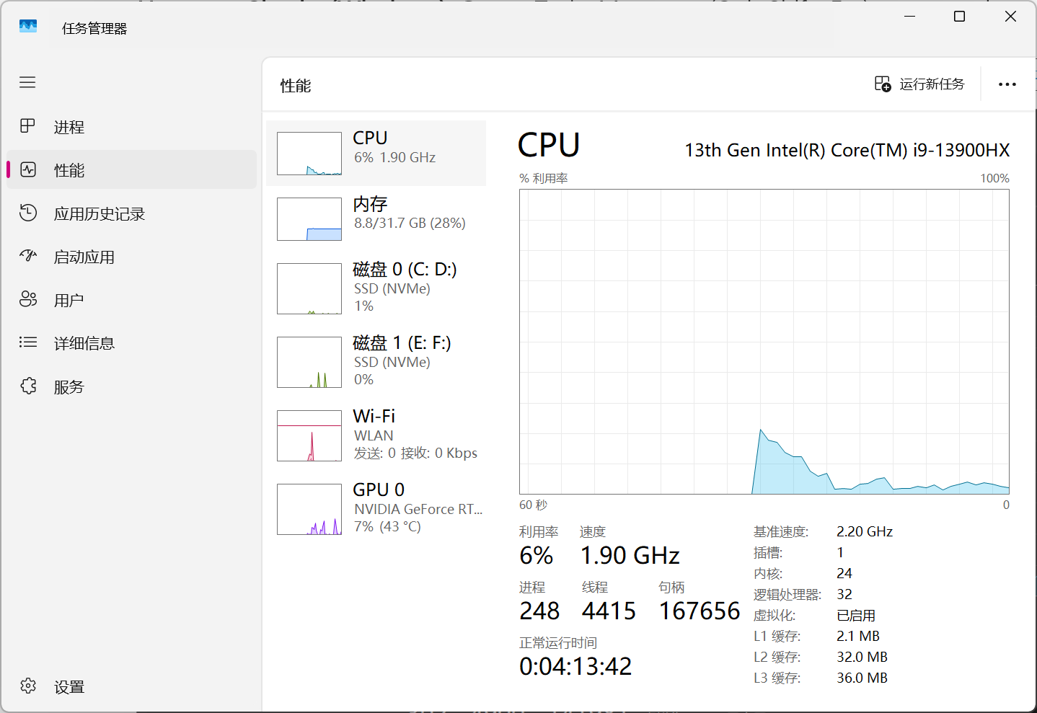

**2. The Cloud: Reasons for Success, Pros, and Cons**

* **Fundamental Reasons for Success:**
  1. **Economic Efficiency:** Shifts IT spending from large capital expenditures (CapEx) on physical hardware to flexible operational expenditures (OpEx), "pay-as-you-go."
  2. **Scalability and Elasticity:** Businesses can instantly scale resources up or down to match demand, which is impossible with physical infrastructure.
  3. **Ease of Access and Global Reach:** Services and data are accessible from anywhere with an internet connection, enabling remote work and global deployment.
* **Three Pros:**
  1. **Cost Savings:** No need to purchase, maintain, or power physical servers.
  2. **Speed and Agility:** Developers can deploy new applications and resources in minutes.
  3. **Reliability and Disaster Recovery:** Data is backed up across redundant sites, making data loss and downtime much less likely.
* **Three Cons:**
  1. **Potential for Unexpected Costs:** Poor resource management can lead to a high bill ("bill shock").
  2. **Security and Compliance Concerns:** Entrusting sensitive data to a third party requires strong trust and contractual agreements.
  3. **Vendor Lock-in:** It can be difficult and expensive to migrate services and data from one cloud provider (e.g., AWS) to another (e.g., Azure).

**3. Primary function of a hypervisor**  
The primary function of a hypervisor (or Virtual Machine Monitor - VMM) is to create, run, and manage virtual machines (VMs). It acts as a layer of software that abstracts the physical hardware, allowing multiple guest operating systems to share a single physical host system's resources.

**4. What is a virtual machine (VM)?**  
A Virtual Machine (VM) is a software-based emulation of a physical computer. It runs its own operating system and applications as if it were a physical machine, but it shares the underlying hardware resources of the host machine, managed by a hypervisor.

**5. Benefits of using virtual machines**

* **Server Consolidation:** Run multiple VMs on one physical server, improving hardware utilization.
* **Isolation:** Applications and OSes in different VMs are isolated from each other, improving security and stability.
* **Portability:** VMs can be easily moved between different physical hosts.
* **Disaster Recovery:** VMs can be backed up and restored easily.
* **Development and Testing:** Developers can test software in isolated environments without affecting their main machine.

**6. Five use cases of virtual machines**

1. **Running legacy software** that requires an older operating system.
2. **Creating isolated sandbox environments** for testing new software or malware analysis.
3. **Consolidating servers** in a data center to save on hardware and energy costs.
4. **Deploying applications** in a consistent and reproducible environment across development, testing, and production.
5. **Providing virtual desktops** to employees, allowing them to access their work environment from any device.

**7. In virtualization, what is the guest operating system?**  
**b) The operating system installed on a virtual machine**

**8. What does virtual machine isolation mean?**  
**c) Virtual machines run independently and are isolated from each other and the host system.**

**9. What is the benefit of virtual machine portability?**  
**c) It allows virtual machines to be moved between different physical machines with compatible hypervisors.**

**10. What is the purpose of cloning a virtual machine?**  
The purpose of cloning a virtual machine is to quickly create an identical copy. This is extremely useful for:

* Rapidly deploying multiple identical systems (e.g., for a cluster of web servers).
* Creating a perfect backup snapshot before making risky changes.
* Reproducing a specific environment for development or troubleshooting.